#
# 20181214
#

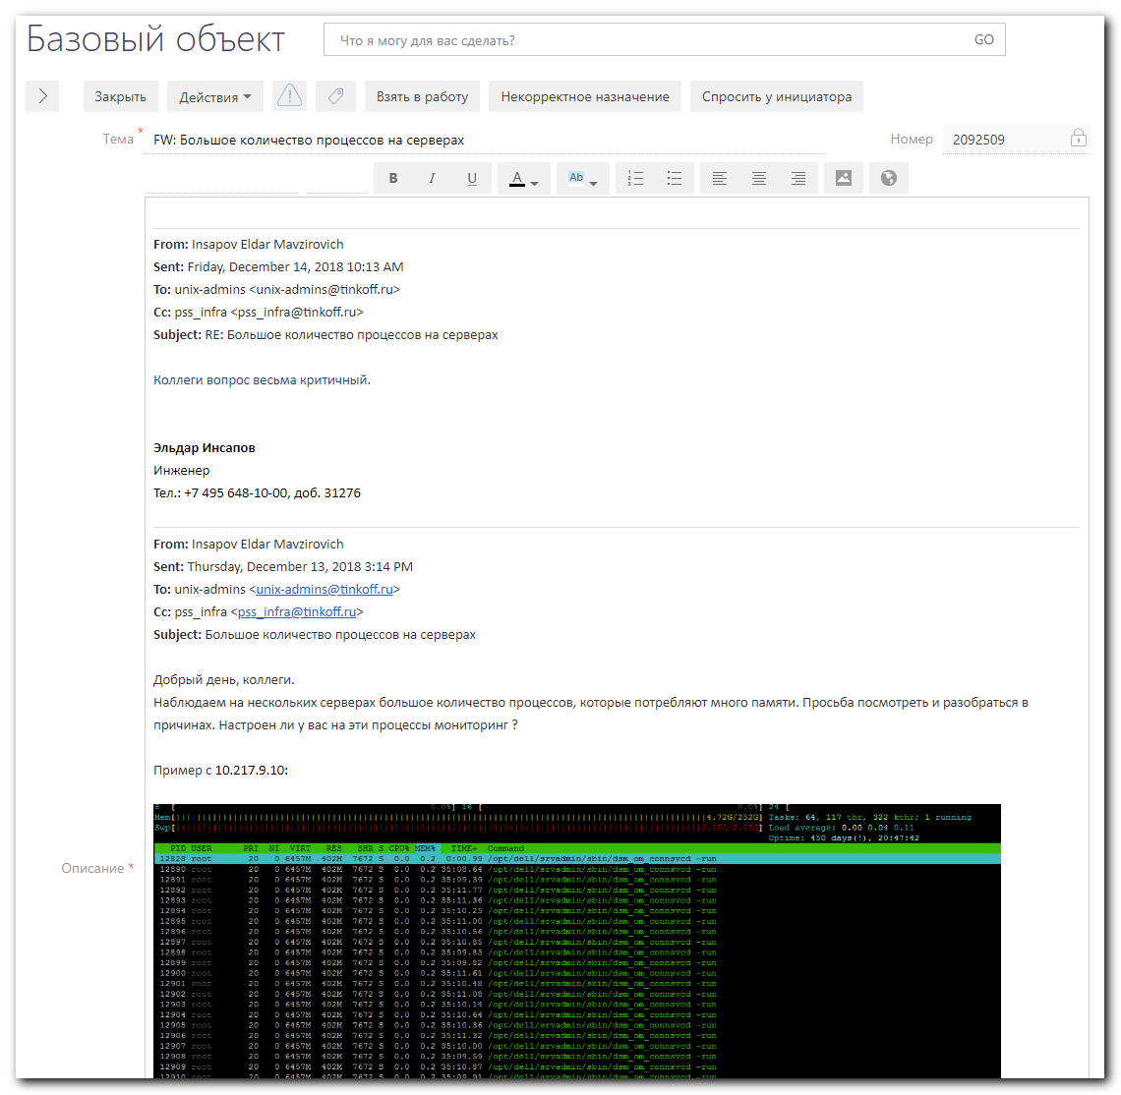
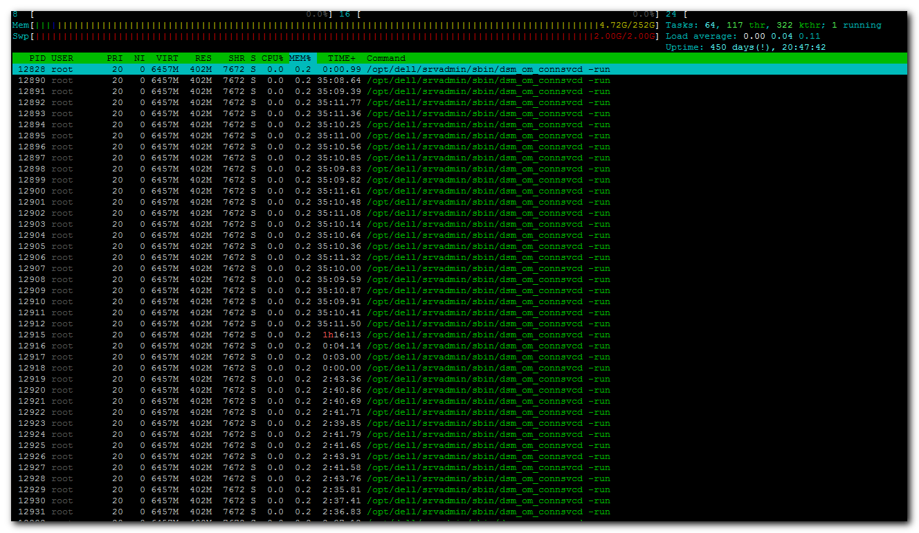

From: Belogrud Sergey Vladimirovich
Sent: Friday, December 14, 2018 12:15 PM
To: Insapov Eldar Mavzirovich <e.insapov@tinkoff.ru>
Cc: pss_infra <pss_infra@tinkoff.ru>; unix-admins <unix-admins@tinkoff.ru>
Subject: RE: Большое количество процессов на серверах

Добрый день.

Сделайте пожалуйста задачу в SD, что и всегда рекомендутся делать.

Не необходимый сервис (процесс) на сервере ds-pr-onltraces01p был отключен.

Состояние потребления памяти процессами до отключения опционального сервиса dsm_om_connsvc.
PID USER VSZ RSS COMMAND
12826 root 6612156 412684 dsm_om_connsvcd
137370 root 791464 24200 dsm_sa_datamgrd
137448 root 725796 19144 dsm_sa_datamgrd
137439 root 511356 5764 dsm_sa_snmpd
137412 root 300940 3672 dsm_sa_eventmgr
12839 root 632376 1036 dsm_om_shrsvcd
12825 root 137896 472 dsm_om_connsvcd

Отключение сервиса dsm_om_connsvc. Это можно сделать на всех серверах, где для вас это критично.
[root@ds-pr-onltraces01p ~]# systemctl stop dsm_om_connsvc
[root@ds-pr-onltraces01p ~]# systemctl disable dsm_om_connsvc

Состояние потребления памяти процессами после отключения опционального сервиса dsm_om_connsvc.
PID USER VSZ RSS COMMAND
138900 root 791332 22824 dsm_sa_datamgrd
140194 root 725664 17832 dsm_sa_datamgrd
140187 root 511356 5748 dsm_sa_snmpd
140160 root 300940 3668 dsm_sa_eventmgr
12839 root 632376 1036 dsm_om_shrsvcd

Вкраце, что есть VSZ, RSS.
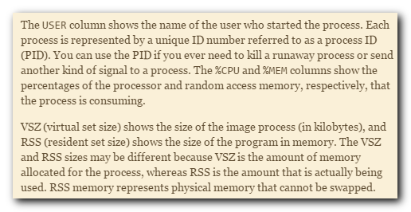
Описание процессов.
https://www.dell.com/support/manuals/us/en/04/dell-openmanage-server-administrator-v8.3/omsa_ug/server-administrator-services?guid=guid-ccdabde1-2904-4aa9-8c9a-9fbcde5df616&lang=en-us


Сергей Белогруд
Старший системный администратор
Тел.: +7 495 648-10-00, доб. 2173

From: Insapov Eldar Mavzirovich
Sent: Friday, December 14, 2018 10:13 AM
To: unix-admins <unix-admins@tinkoff.ru>
Cc: pss_infra <pss_infra@tinkoff.ru>
Subject: RE: Большое количество процессов на серверах

Коллеги вопрос весьма критичный.

Эльдар Инсапов
Инженер
Тел.: +7 495 648-10-00, доб. 31276

From: Insapov Eldar Mavzirovich
Sent: Thursday, December 13, 2018 3:14 PM
To: unix-admins <unix-admins@tinkoff.ru>
Cc: pss_infra <pss_infra@tinkoff.ru>
Subject: Большое количество процессов на серверах

Добрый день, коллеги.
Наблюдаем на нескольких серверах большое количество процессов, которые потребляют много памяти. Просьба посмотреть и разобраться в причинах. Настроен ли у вас на эти процессы мониторинг ?

Пример с 10.217.9.10:

Эльдар Инсапов
Инженер
Тел.: +7 495 648-10-00, доб. 31276

#
# Related articles.
#
https://marc.info/?l=linux-poweredge&m=134117343231516
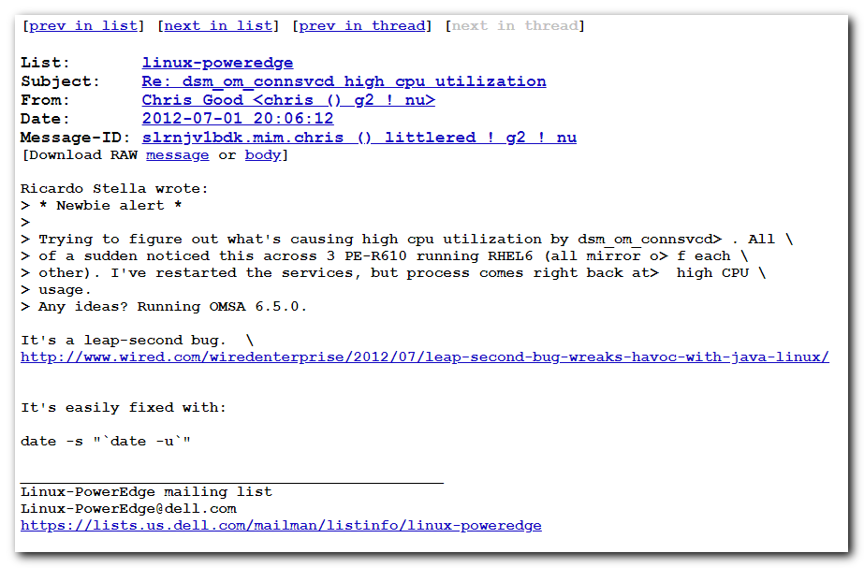

https://serverfault.com/questions/641855/dell-openmanage-web-interface-inaccessible
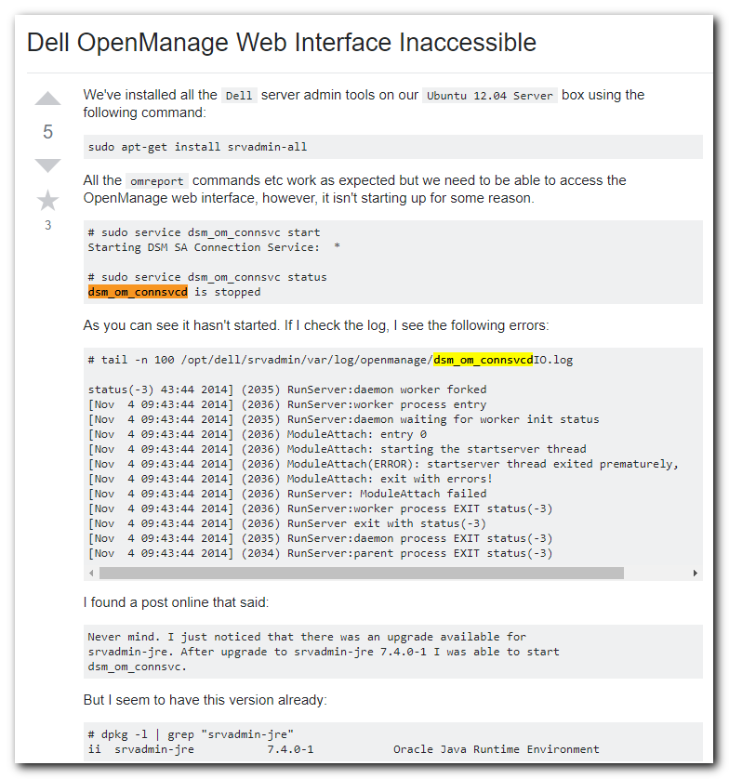

https://www.dell.com/support/manuals/us/en/04/dell-openmanage-server-administrator-v8.3/omsa_ug/server-administrator-services?guid=guid-ccdabde1-2904-4aa9-8c9a-9fbcde5df616&lang=en-us
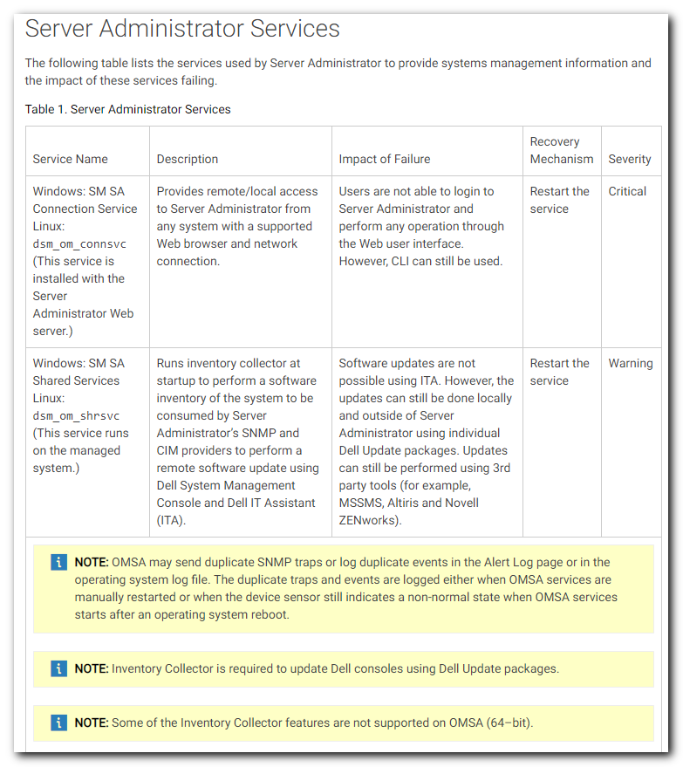
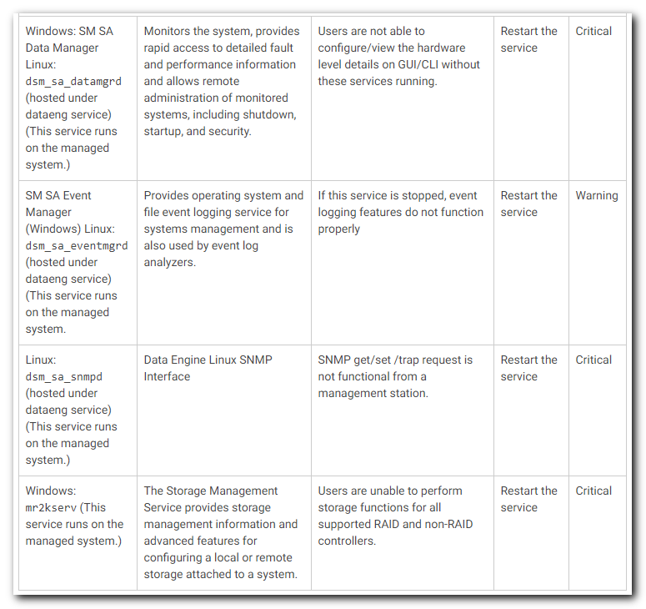

Dell OpenManage Server Administrator Version 8.3 User's Guide

Server Administrator Services
The following table lists the services used by Server Administrator to provide systems management information and the impact of these services failing.
Service Name | Description | Impact of Failure | Recovery Mechanism | Severity
Windows: SM SA Connection Service Linux:dsm_om_connsvc(This service is installed with the Server Administrator Web server.) | Provides remote/local access to Server Administrator from any system with a supported Web browser and network connection. | Users are not able to login to Server Administrator and perform any operation through the Web user interface. However, CLI can still be used. | Restart the service | Critical
Windows: SM SA Shared Services Linux:dsm_om_shrsvc(This service runs on the managed system.) | Runs inventory collector at startup to perform a software inventory of the system to be consumed by Server Administrator’s SNMP and CIM providers to perform a remote software update using Dell System Management Console and Dell IT Assistant (ITA). | Software updates are not possible using ITA. However, the updates can still be done locally and outside of Server Administrator using individual Dell Update packages. Updates can still be performed using 3rd party tools (for example, MSSMS, Altiris and Novell ZENworks). | Restart the service | Warning
- NOTE: OMSA may send duplicate SNMP traps or log duplicate events in the Alert Log page or in the operating system log file. The duplicate traps and events are logged either when OMSA services are manually restarted or when the device sensor still indicates a non-normal state when OMSA services starts after an operating system reboot.
- NOTE: Inventory Collector is required to update Dell consoles using Dell Update packages.
- NOTE: Some of the Inventory Collector features are not supported on OMSA (64–bit).
Windows: SM SA Data Manager Linux:dsm_sa_datamgrd(hosted under dataeng service) (This service runs on the managed system.) | Monitors the system, provides rapid access to detailed fault and performance information and allows remote administration of monitored systems, including shutdown, startup, and security. | Users are not able to configure/view the hardware level details on GUI/CLI without these services running. | Restart the service | Critical
SM SA Event Manager (Windows) Linux:dsm_sa_eventmgrd(hosted under dataeng service) (This service runs on the managed system. | Provides operating system and file event logging service for systems management and is also used by event log analyzers. | If this service is stopped, event logging features do not function properly | Restart the service | Warning
Linux:dsm_sa_snmpd(hosted under dataeng service) (This service runs on the managed system.) | Data Engine Linux SNMP Interface | SNMP get/set /trap request is not functional from a management station. | Restart the service | Critical
Windows:mr2kserv (This service runs on the managed system.) | The Storage Management Service provides storage management information and advanced features for configuring a local or remote storage attached to a system. | Users are unable to perform storage functions for all supported RAID and non-RAID controllers. | Restart the service | Critical

